وزارة التعليم العالي والبحث العلمي

Ministry of Higher Education and Scientific Research

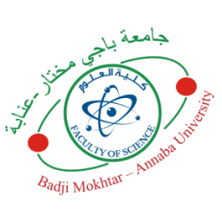

BADJI MOKHTAR-ANNABA
UNIVERSITY
مختار
بـاجي

جامعة

UNIVERSITE BADJI MOKHTAR
ANNABA

Faculty of Sciences
Department of Mathematics

عنابة- -

Year: 2023/2024


THESIS
Presented with a view to obtaining the doctorate degree

Title
Stream
Applied Mathematics

Speciality
Probability and Statistics

By
.....................
SUPERVISOR: Prof. U.B.M.- Annaba
In front of the jury

PRESIDENT: Prof. U.B.M.- Annaba
EXAMINER: Prof. U.B.M. - Annaba
EXAMINER: Prof. U.S.B.- Constantine 3
EXAMINER: Prof. U.B.M. - Annaba
GUESS: Prof. ENSIA - Algiers

